Software Requirements Specification

for

Eyewitness Website

**Version 1.0 approved**

**Prepared by Khyati Chaudhari, William Craddock, and Aman Patel**

**Western Kentucky University**

**1/31/2022**

**Table of Contents**

**1. Introduction** **1**

**1.1 Purpose** **1**

**1.2 Document Conventions** **1**

**1.3 Intended Audience and Reading Suggestions** **1**

**1.4 Product Scope** **2**

**1.5 References** **2**

**2. Overall Description** **2**

**2.1 Product Perspective** **2**

**2.2 Product Functions** **2**

**2.3 Use Cases** **3**

**2.4 User Classes and Characteristics** **4**

**2.5 Operating Environment** **5**

**2.6 Design and Implementation Constraints** **5**

**2.7 User Documentation** **5**

**2.8 Assumptions and Dependencies** **5**

**3. External Interface Requirements** **6**

**3.1 User Interfaces** **6**

**3.2 Hardware Interfaces** **6**

**3.3 Software Interfaces** **6**

**3.4 Communications Interfaces** **6**

**4. System Features** **6**

**4.1 Drag and Drop** **6**

**4.1.1 Description and Priority** **6**

**4.1.2 Stimulus/Response Sequences** **7**

**4.1.3 Functional Requirements** **7**

**4.2 Time Recording** **7**

**4.2.1 Description and Priority** **7**

**4.2.2 Stimulus/Response Sequences** **7**

**4.2.3 Functional Requirements** **7**

**4.3 Interchangeable Photo** **7**

**4.3.1 Description and Priority** **7**

**4.3.2 Stimulus/Response Sequences** **7**

**4.3.3 Functional Requirements** **7**

**4.4 Confidence Rating** **7**

**4.4.1 Description and Priority** **7**

**4.4.2 Stimulus/Response Sequences** **8**

**4.4.3 Functional Requirements** **8**

**4.5 Login/Logout** **8**

**4.5.1 Description and Priority** **8**

**4.5.2 Stimulus/Response Sequences** **8**

**4.5.3 Functional Requirements** **8**

**5. Other Nonfunctional Requirements** **8**

**5.1 Performance Requirements** **8**

**5.1.1 Normalization** **9**

**5.2 Safety Requirements** **9**

**5.3 Security Requirements** **9**

**5.4 Software Quality Attributes** **9**

**5.4.1 Adaptability** **9**

**5.4. 2 Compatibility** **9**

**5.4. 3 Usability** **9**

**5.5 Business Rules** **10**

**5.5.1 Super-User Role Business Rules** **10**

**5.5.2 User Role Business Rules** **10**

**6. Other Requirements** **10**

**Conceptual Design of Eyewitness Database** **11**

**Revision History**

| **Name** | **Date** | **Reason For Changes** | **Version** |
| --- | --- | --- | --- |
|  |  |  |  |
|  |  |  |  |

# 1. Introduction

## 1.1 Purpose

In this document we are giving system specific requirements for the website we are building for our final project. The website is meant to help law enforcement when dealing with a case where an eyewitness has seen a suspect and helps eyewitnesses better identify suspects. Our website will be a key tool joining eyewitness information to law enforcement directly. And in this document, we have designed all the functional requirements we think are necessary along with the non- functional requirements like performance, security, and safety issues we might think we might encounter at this initial stage and in future and will also come up with the solution of that problem.

## 1.2 Document Conventions

As I mentioned earlier, the team has finalized the initial requirements for the project at this stage and that’s what the focus for this document is. But for the basic documentation specification, we are following the IEEE standard provided to us with font size 11 and font is Arial. Most elaborated and most important section of the document will be the requirements section where each requirement will be a priority and will be explained in detail on how they will be implemented. Each requirement will be given a necessary amount of thought and consideration. As we mentioned earlier the set of requirements provided in this document are what the team has finalized on the initial stage of the project which is subject to change in the future. For the entirety of the project all the documentation will be presented in the similar format to this to make things simple and easy to understand. Other than this Software Requirements Specification documentation team will keep all the information on how the team is progressing during the time working on the project and will keep the client updated in a timely manner. Also, along with this documentation client will also get the weekly progress report about the project and how the team is working, briefly every week and what they are planning to do in the coming weeks.

## 1.3 Intended Audience and Reading Suggestions

For the project itself we are expecting all the people who have unfortunately seen some crime in progress and are willing to come forward and identify the possible suspect, law enforcement, and government is the audience for this project but for this specific documentation our audience are team members, other teams from our class, our client Dr. Xia and Dr. Baker who came up with this brilliant idea. We would suggest the top-down approach for this documentation starting from the first section and proceeding further down. But the most important sections of this document that nobody should skip are Section 2 “Overall Description” and Section 3 “External Interface Requirements” and Section 6 “Non-Functional Requirements.” These three sections are the core of this document, we are not saying all the other sections are useless but these three are the most important and the most meaningful. Section 2 will describe our project in detail and describe more thoroughly giving more technical detail on how we will implement the project. Section 3 will go over some of the specific requirements that are important for the project. And section 6 will go over non-functional requirements like how we will test our website’s performance, database performance and how safe and secure our database is from hackers and malwares.

## 1.4 Product Scope

As mentioned in the abstract of our project, we are building this website to help witnesses better help our law enforcement with the piece of information they have about the crime or criminal. Moreover, our website will help establish a tool where witnesses can instantly help law enforcement with the case by identifying the picture of the criminal from the criminal database. Scope of the project as of now is limited to the suspect identification and not help with other case related information. But the future goal for the project will be to make it where law enforcement can use it as their primary workstation.

## 1.5 References

* docs.djangoproject.com

# 2. Overall Description

## 2.1 Product Perspective

Idea behind this project was originally thought by Dr. Melissa Baker who is professor here at Western Kentucky University, she has a PhD in psychology, and she is doing research on this topic and we were introduced to this project by our professor Dr. Xia. Basic idea of this project is to create a website where law enforcement can store their criminal record and according to the description given by the witness website generates a list of names along with pictures. After which the user selects all the possible suspects and submits to the law enforcements database which helps them in their investigation. Following the basic layout of the website we think we will be building.

## 2.2 Product Functions

1. The number of photos in the lineup needs to be easily changeable (i.e., 1 face vs. 6 faces)
2. How the photos are inserted into the lineup need to be drag and drop (i.e., officers can drag and drop photos matching the suspect's description in the lineup)
3. The program needs to record the amount of time (in seconds) it takes for a witness to make an identification decision (i.e., this could be a measure of clicking the mouse or a touch screen measure)
4. The program needs to record the witness’ confidence in their lineup identification decision
5. Witness will be able to log in to their account
6. Officers will be able to login to their account

## 2.3 Use Cases

In this section we will discuss how our product will react in different scenarios by giving different use cases and then we will map where functional requirements are used and why they are necessary for this project. First we will give a table of a use case scenario and then we will give a diagram of the scenario and after all the Use cases we will provide a requirement mapping table.

| Use Case: Eye-witness Website |
| --- |
| ID: UC1 |
| Actors: Officer, Witness |
| Preconditions: |
| 1. Primary Scenario: 2. Officer logs in as an administrator 3. Creates a new case file 4. Adds new witness and assigns case to witness 5. Then according to the description the witness provided, the officer sorts the picture and lines-up those to the witness account he created. 6. Give that information to witness. |
| Secondary Scenario:   1. Error logging in 2. Error creating new case 3. Error creating new witness 4. Error lining up pictures |

| Use Case: Eye-witness Website |
| --- |
| ID: UC2 |
| Actors: Officer, Witness |
| Preconditions: Witness account created |
| 1. Primary Scenario: 2. Officer gives login information to witness 3. Witness logs in to their account 4. Selects the case 5. Timer will begin when pictures are visible to witness 6. Witness will select all the familiar looking suspects 7. As the witness is selecting the suspect and submitting them, he will be asked to be surety in their decision on scale 1 to 10. 8. User logs out. |
| Secondary Scenario:   1. Error logging in 2. Error giving rating 3. Error saving pictures |

| Requirements | R1 | R2 | R3 | R4 | R5 | R6 |
| --- | --- | --- | --- | --- | --- | --- |
| UC1 | ✔ | ✔ |  |  |  | ✔ |
| UC2 |  |  | ✔ | ✔ | ✔ |  |

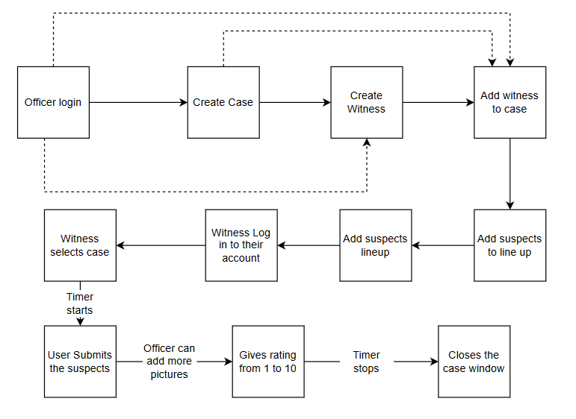

## 2.4 User Classes and Characteristics

There are two user classes who will be using the finished products. The first and most important user class is the law enforcement who will be using this website as a tool when eye-witness comes up to identify a suspect. Second user class are the witnesses who have seen crime and criminals and are able to help out law enforcement by identifying the suspect and giving the ratings on how good their prediction is. Since eye-witness does not have to be well educated and anyone could be one so our goal for this product is to make the website as easy to understand as possible and that is why we will have two different interfaces one will be for general public/ witnesses and second interface will be for law enforcement, which could be little complex with more features. Law interface will have the top-level privilege with features like adding criminals to the database or removing one and also creating a lineup for witnesses to identify. On the other hand, witnesses will have fewer privileges.

## 2.5 Operating Environment

As we are creating a website it will be able to open on any device that have a browser and external software needed to coexist with our website and actually make it meaningful is database, as on the initial base we will be creating a locally hosted database but as we move forward, we anticipate to host our database and website on an online server. But for law enforcement purposes we think they need to host their database from their private server to minimize the data theft problem.

## 2.6 Design and Implementation Constraints

Our biggest fear for this project is the time, because we just have a semester worth of time to complete this project. But because of this we have considered that we will make the project in working condition and start all the testing processes alongside each other which will help us complete this project in time. Also, we are trying to build the product and design it at the same time also. But our goal is to complete the basic product that we pitched first and then work on adding extra features to it once the initial product is ready to deploy. But other smaller speed bumps that we have in mind are like what if we are not able to allocate time to the project that we anticipated at the beginning of the course. For example, due to snow our team did not meet in-person as decided but instead we met online over the zoom so we are not that afraid of these smaller problems along the way, because we are prepared for it.

## 2.7 User Documentation

As of now we were thinking of creating a user manual which allows users to understand how to use our system. So, we will have two manuals, one for law enforcement and other for eye-witness. Law enforcement will have a few different sections which will explain how each feature works and how to use them. And for eye-witness there will be just one section which will tell the user how to log in and identify the suspect. If we have time left, we will create a web-page which will be available on the website at all times which could be useful to all users at all times.

## 2.8 Assumptions and Dependencies

As for the software side we do not think there are any dependencies because, team will be building the website and database to go along with it themselves. But the Raw-data and the volunteers required for the testing of our website will be provided by Dr. Melissa Baker who is the person who thought of this project. If for some reason she is not able to provide either of those things to use we might be delayed a bit until we find other resources. But after a video call with her we are comfortable saying that we completely trust her on her words and there won't be any problem on that side of the project.

# 3. External Interface Requirements

## 3.1 User Interfaces

The main user interface for the witness will consist of a drop-down menu where the user can input different selection choices pertaining to different character features such as eye color and height. After the user has submitted their information a selection of photos will be presented based on the data they put in. The user then will be able to click and submit photos.

The main user interface for the police officer will consist of uploading pictures into the database and being able to look up different case files. When the officer uploads a photo he will then input characteristics matching the photo with a drop down menu. It is with these characteristics that they will know what photos to pull from the database for the witness.

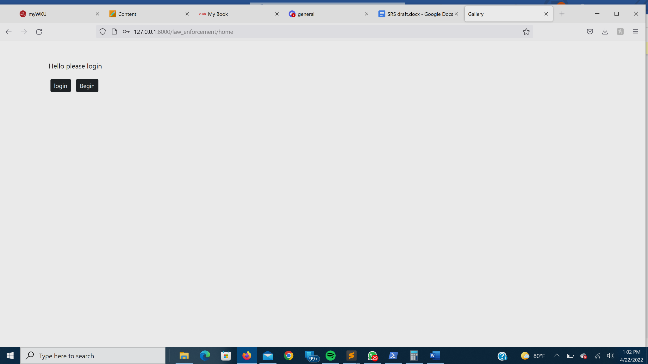

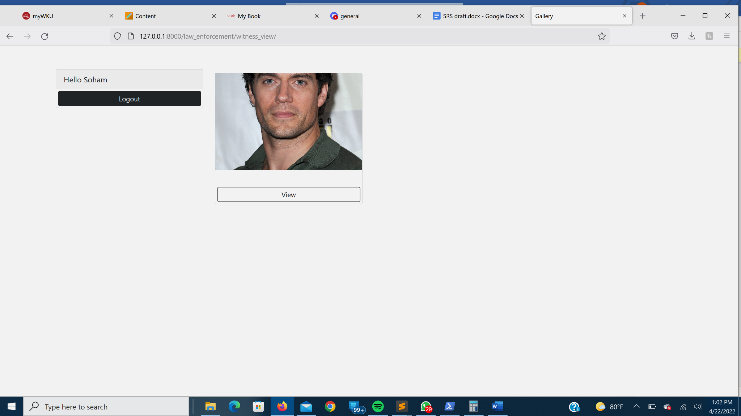

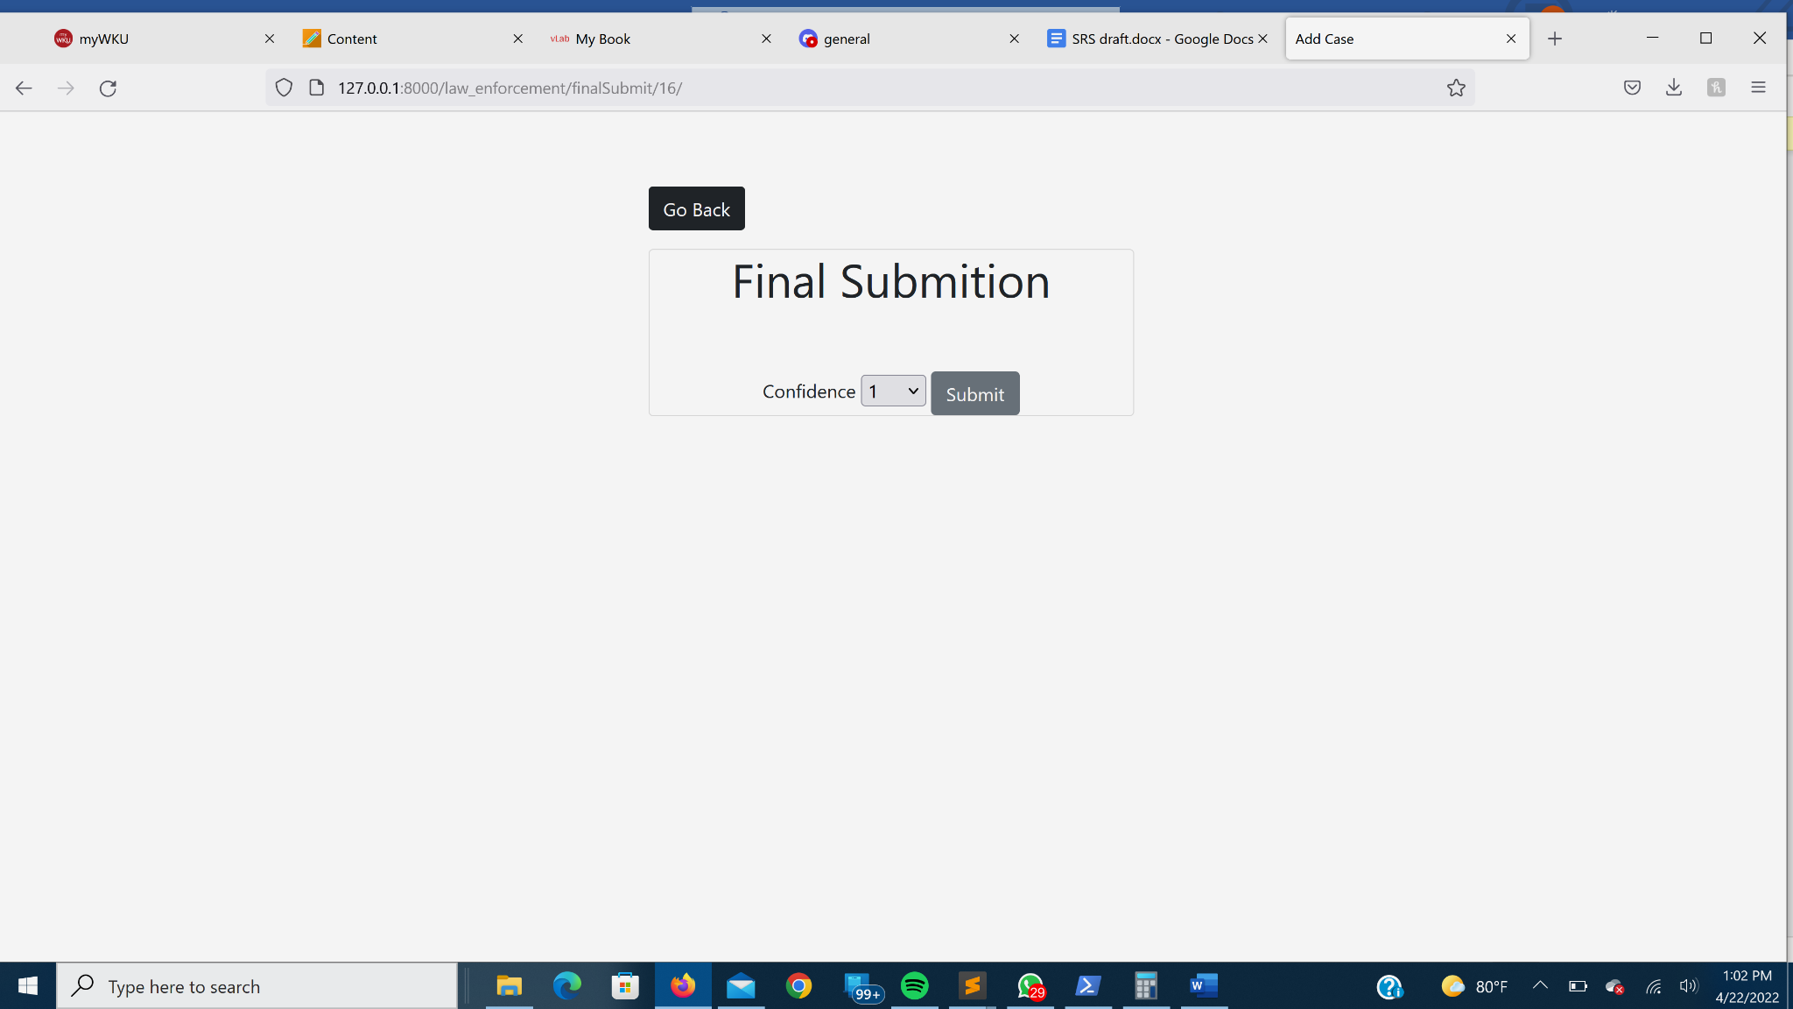

*Witness Interface*

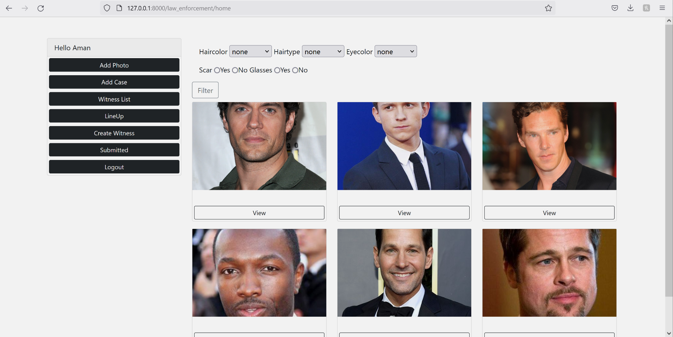

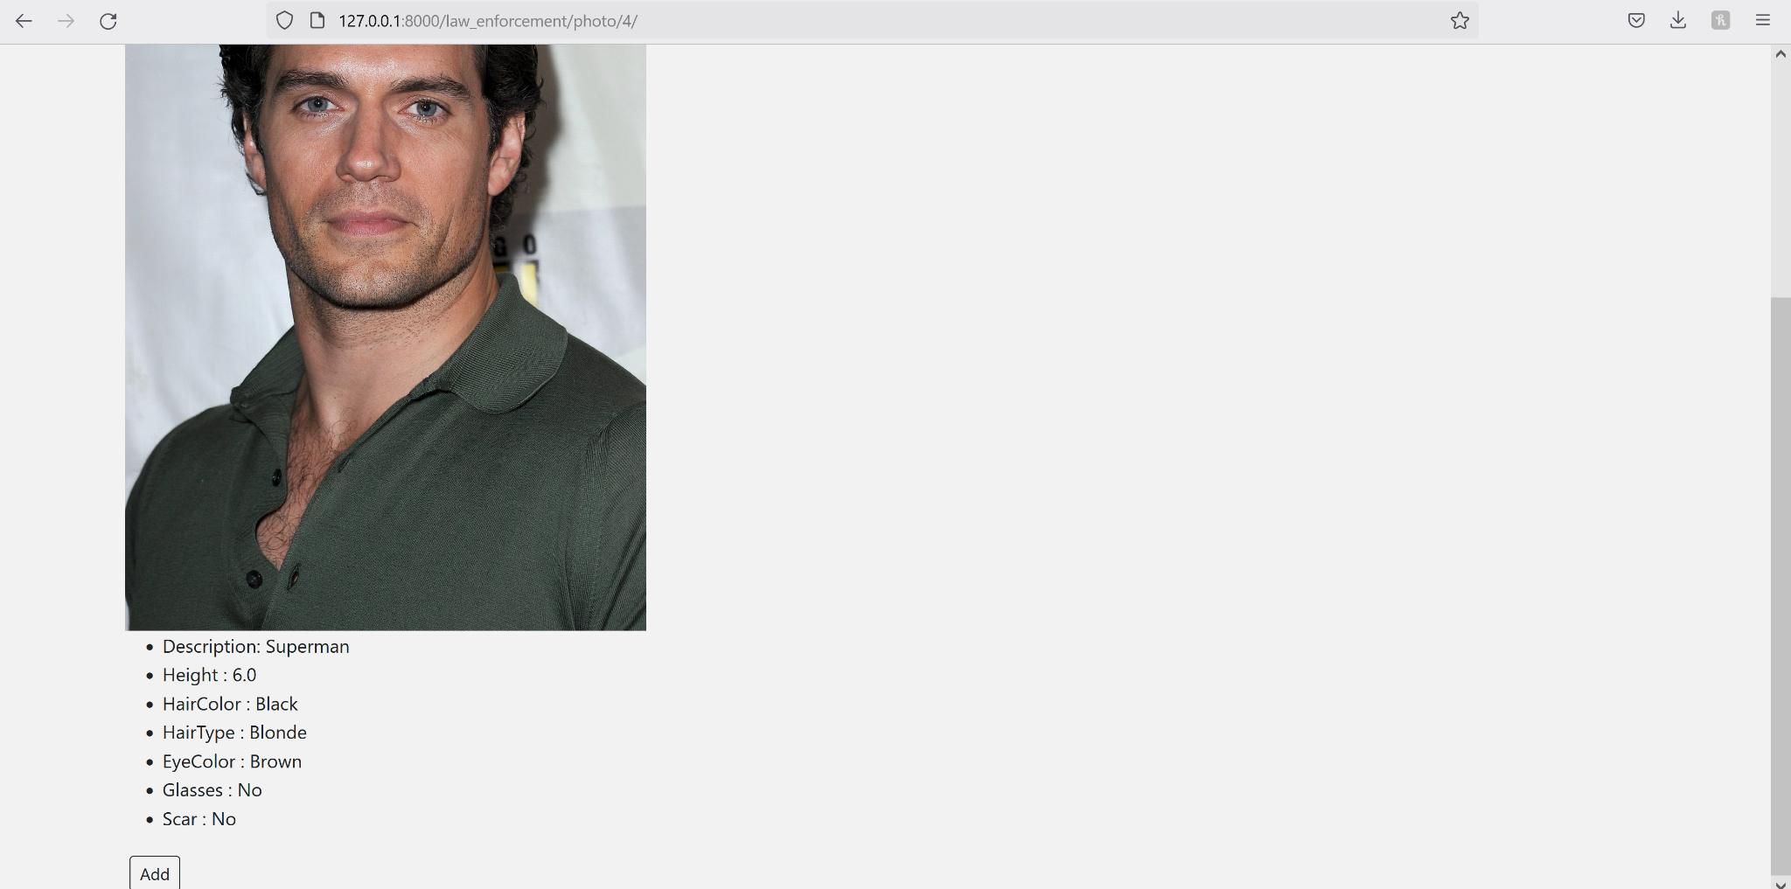

*Law Enforcement Interface*

## 3.2 Hardware Interfaces

The main hardware device that we plan on implementing this for is for a windows pc. If we have time, we plan on implementing the program for mac and Linux.

We also plan on the main tool for the user to interact with the program to be through the use of the mouse and keyboard. If time permits, we plan on implementing touch screens as a prominent feature.

## 3.3 Software Interfaces

As stated, we mainly plan on utilizing our program on windows pc. The main program we are going to use to build our website is going to be Django. Django offers the most flexibility in building website pages and our group is more familiar with how it works. The code which we will be using will be python to construct the website and HTML to construct the web pages. We plan on using SQL as our database. We all have experience using SQL. Django and SQL are also very compatible.

## 3.4 Communications Interfaces

As for right now we plan on having the website run on a local server. If we have time, we plan on fully launching the website. We plan on using the HTTP format. We will make changes to the website by using command script.

# 4. System Features

## 4.1 Drag and Drop

### **4.1.1** **Description and Priority**

This feature will consist of the ability to drag and drop pictures as a way of adding into the database. This feature is a high priority because it was directly asked for by the client.

### **4.1.2** **Stimulus/Response Sequences**

The admin will click and drag a picture with the mouse to the designated target area.

### **4.1.3** **Functional Requirements**

This feature will require the use of just the mouse.

## 4.2 Time Recording

### **4.2.1** **Description and Priority**

We will be recording the time it takes for a witness to make a decision about the photos and how long it takes them to submit the confidence rating. This feature is also, high priority because the client asked for it directly.

### **4.2.2** **Stimulus/Response Sequences**

We will have a timer start as soon as the user is able to start picking photos and choose their confidence rating. The timer will stop when the user clicks on the submit button.

### **4.2.3** **Functional Requirements**

The program needs to record the amount of time (in seconds) it takes for a witness to make an identification decision (i.e., this could be a measure of clicking the mouse or a touch screen measure)

## 4.3 Interchangeable Photo

### **4.3.1** **Description and Priority**

The photos that are submitted to the database and picked by the admin will be able to be easily interchangeable. This feature is a medium priority.

### **4.3.2** **Stimulus/Response Sequences**

This feature will be using the drag and drop feature to easily exchange pictures into the database.

### **4.3.3** **Functional Requirements**

TBD

## 4.4 Confidence Rating

### **4.4.1** **Description and Priority**

After the user has picked the photos, they will have to rate their confidence on a scale of 1 to 5 with 5 being most confident and 1 being least confident.

### **4.4.2** **Stimulus/Response Sequences**

This feature will consist of redirecting to a different page where the user will input their confidence rating. This interaction will be timed as this is also a requirement requested by the client.

### **4.4.3** **Functional Requirements**

TBD

## 4.5 Login/Logout

### **4.5.1** **Description and Priority**

The police user and the witness user will be able to login and out of profiles they will be able to set. Each profile will have a different level of authority on what they are able to access within the database.

### **4.5.2** **Stimulus/Response Sequences**

This feature will consist of the user creating a username and password which will be stored in the database. Using these login credentials, the user will be able to login.

### **4.5.3** **Functional Requirements**

The requirement for this feature is connecting the database to the website and making sure the user credentials are checked with the ones in the database when logging in.

# 5. Other Nonfunctional Requirements

## 5.1 Performance Requirements

Django is a very handy tool that provides insights into what your code is doing and how much time it spends doing it. It can show you all the SQL queries your page is generating, and how long each one has taken. Django’s [caching framework](https://docs.djangoproject.com/en/4.0/topics/cache/) offers very significant opportunities for performance gains, by saving dynamic content so that it doesn’t need to be calculated for each request. SQLite provides an excellent development alternative for applications that are predominantly read-only or require a smaller installation footprint.

SQLite works great as the database engine for most low to medium traffic websites (which is to say, most websites). The amount of web traffic that SQLite can handle depends on how heavily the website uses its database. Any site that gets fewer than 100K hits/day should work fine with SQLite. The 100K hits/day figure is a conservative estimate, not a hard upper bound. SQLite has been demonstrated to work with 10 times that amount of traffic

### 5.1.1 Normalization

The basic objective of normalization is to reduce redundancy which means that information is to be stored only once. Storing information several times leads to wastage of storage space and increase in the total size of the data stored. We are using the third normal form for our database to reduce the redundancy.

## 5.2 Safety Requirements

If there is extensive damage to the database due to catastrophic failure, such as a disk crash, the recovery method restores a past copy of the database that was backed up and reconstructs a more current state by reapplying or redoing the operations of committed transactions from the backed-up log, up to the time of failure.

## 5.3 Security Requirements

SQL injection is a type of attack where a malicious user can execute arbitrary SQL code on a database. This can result in records being deleted or data leakage. Django’s query sets are protected from SQL injection since their queries are constructed using query parameterization.

The users of the website are law enforcement officers and eyewitnesses. Each user will have their different username and password. Without logging in to their account they will not have any access to any information. Only law enforcement officers have access to all eyewitness, suspects, and casefiles information. Also, only law enforcement officers can edit and delete case files and suspect information in the system. Eyewitnesses will have access to only pictures of the suspect according to their description.

## 5.4 Software Quality Attributes

### 5.4.1 Adaptability

This website will fulfill the requirements of the users. Law enforcement officers can add the information of cases and suspects just by filling out the section of the form online and can add the pictures of the suspects just by drag and drop. Also, eyewitnesses can browse the pictures of suspects and confirm the suspect just by selecting the picture and clicking the submit button.

### 5.4. 2 Compatibility

This website can be accessed by using any Windows laptop or desktop. Also, more than one user can login at a one time and can access the data according to their permission status.

### 5.4. 3 Usability

This website is very user friendly, and can be accessed from anywhere where one has internet connection. The user interface is very easy to use, where most of the fields are drop-down menus and/or drag and drop.

## 5.5 Business Rules

There are more than one type of users of this website. The super-user is a law enforcement officer, and the other user is an eyewitness. Following are some basic business rules for user roles.

### 5.5.1 Super-User Role Business Rules

SuperUseRole / 001: Have access to all information of all users.

SuperUseRole / 002: Can create a case file.

SuperUseRole / 003: Can edit case information.

SuperUseRole / 004: Can delete case file.

SuperUseRole / 005: Can create a suspect file.

SuperUseRole / 006: Can edit suspect information.

SuperUseRole / 007: Can delete suspect file.

SuperUseRole / 008: Can edit eyewitness access permissions.

SuperUseRole / 009: After quitting the job or retirement does not have any access to any information.

### 5.5.2 User Role Business Rules

UserRole/ 001: Have access to only pictures of the suspects.

UserRole/ 002: Can submit more than one picture of the suspect for one case.

UserRole/ 003: Does not have access to any other user’s information.

UserRole/ 004: Does not have access to any other information of the case other than pictures of the suspects.

# 6. Other Requirements

*<Define any other requirements not covered elsewhere in the SRS. This might include database requirements, internationalization requirements, legal requirements, reuse objectives for the project, and so on. Add any new sections that are pertinent to the project.>*

**Appendix A: Glossary**

*<Define all the terms necessary to properly interpret the SRS, including acronyms and abbreviations. You may wish to build a separate glossary that spans multiple projects or the entire organization, and just include terms specific to a single project in each SRS.>*

**Appendix B: Analysis Models**

## Conceptual Design of Eyewitness Database

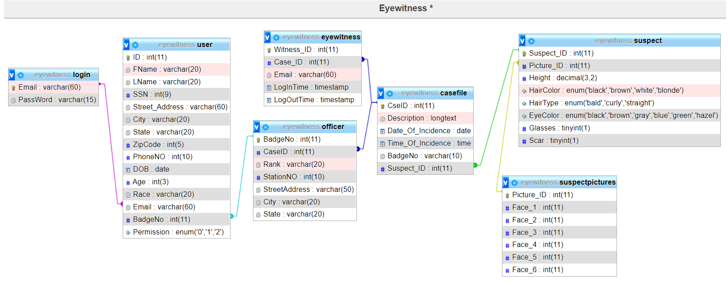

**Appendix C: To Be Determined List**

*<Collect a numbered list of the TBD (to be determined) references that remain in the SRS so they can be tracked to closure.>*